Design wallet management system

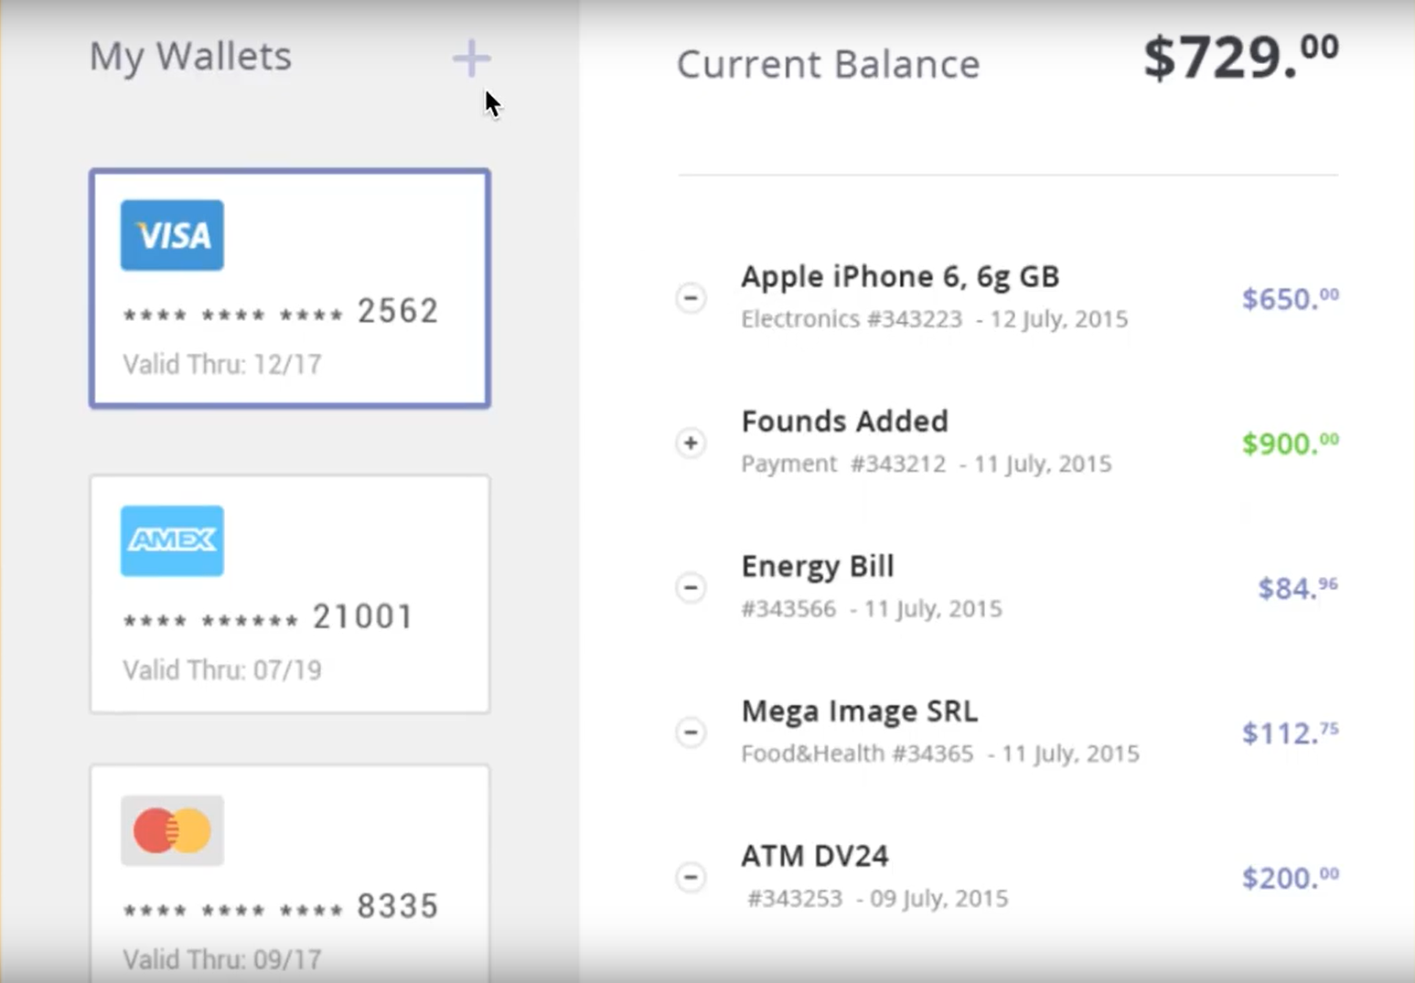

CREDIT CARD LIST REQUIREMENTS -

* Design a system where user can add credit cards using a pop-up form which is triggered on clicking + icon on top.
* In your layout left column will contain list of all credit cards and on the right will be list of all transactions for that card.
* On clicking a card I should be able to see all the transactions on the right side of screen.
* Any card that is expired should have a warning OR a badge text with red color to mark it INACTIVE.

TRANSACTION LIST REUIREMENTS -

* If $ is more than 900 mark it red
* If a payment was already made mark $ green
* If unpaid then leave it blue
* Each row contains – icon on left to collapse/expand details for transaction. For detail just show payment id and description.
* CURRENT BALANCE on top should show all the payments that are unpaid.
* Use dummy JSON data to show transaction on right. So on click of credit card right list will show static data.

Notes-

* Design system using separate components
* Your design should be responsive
* Validation checks should be in place.
* Design proper JSON structure to illustrate cards and their transaction
* For any new card you add you don’t have to show data on right but the card should show up on left list.
* Your application should have at least 2 card pre-loaded for review.